**Name & Numbering System**

Package #

Template Code: A_AA_A_#_#_####_####_A_####

Code Meaning: A AA # # #### #### A ####

# of

Wheels

Documentation/

Revision #

Item #

Model #

# of Doors

Body Type

Color

**Name & Numbering Example**

GY_CP_2_4_1_1_P_0001

GY = Gray

CP = Coupe

2 = # of Doors

4 = # of Wheels

1 = Item #

1 = Model #

P = Package # (Indicates Size)

0001 = Documentation #

**Documentation System**

Documentation Code: A_A_####/T_####

Code Meaning: A A ####/T ####

Document #

/Template

Revision #

Person Responsible

(Initials)

Document Type

**Documentation Example**

ECR_RJE3_T

ECR = Engineering Change Request

RJE3 = Robert J. Esposito III

T = Template

*** No document or revision # because this is a template document ***

**Color Coding Abbreviations**

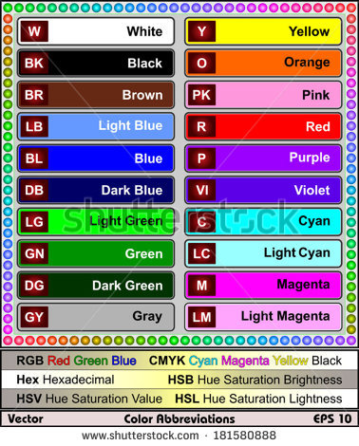

**Vehicle Type Abbreviations**

SED = Sedan

SUV = Sports Utility Vehicle

VAN = Mini Van

UVAN = Utility Van

CP = Coupe/Sport Car

PT = Pick-Up Truck

TT = Tractor Trailer

EMV = Emergency Vehicle

CSTN = Construction